Homemove
Customer Portal and Bidding

You can only log in if you have received a band and your case has been activated- status LIVE
https://www.homemove.org.uk/customer-login
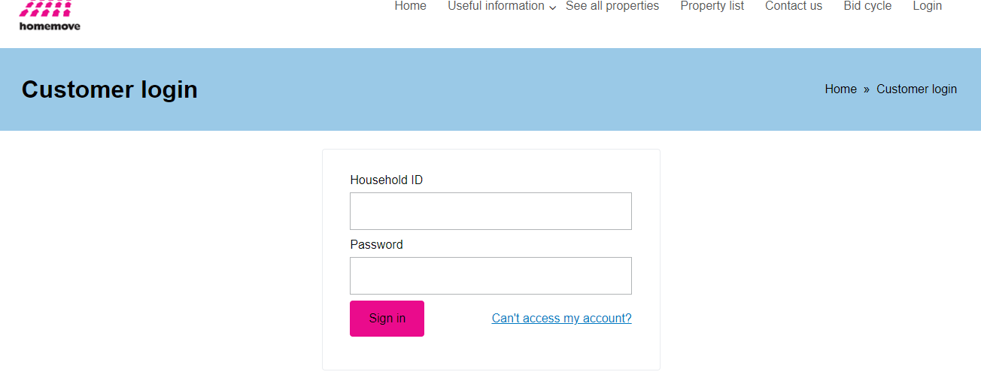

Enter your household and password
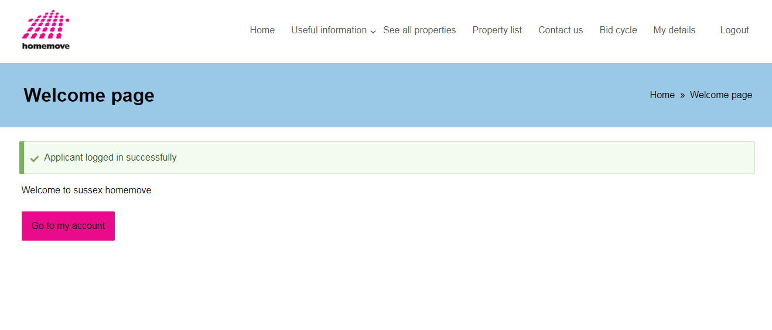
Go to the account
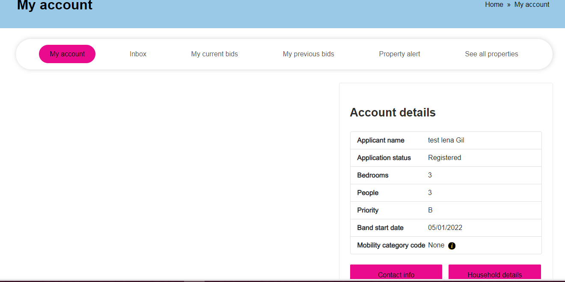

Search for properties
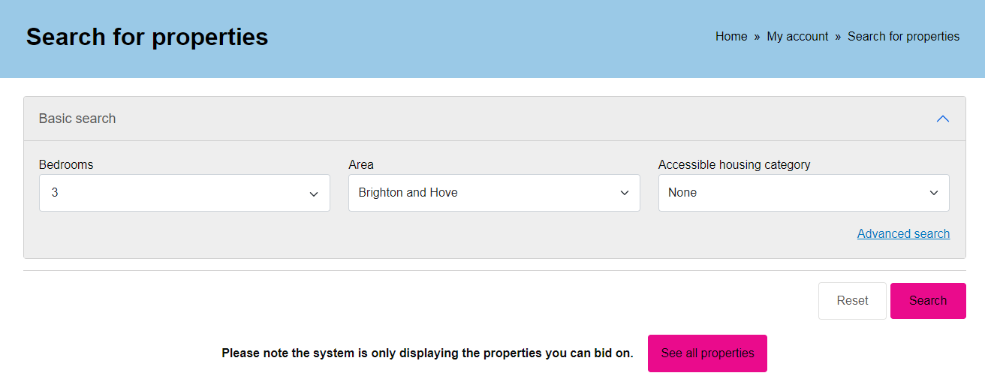

Select your choices and search- See the list and click Full property details
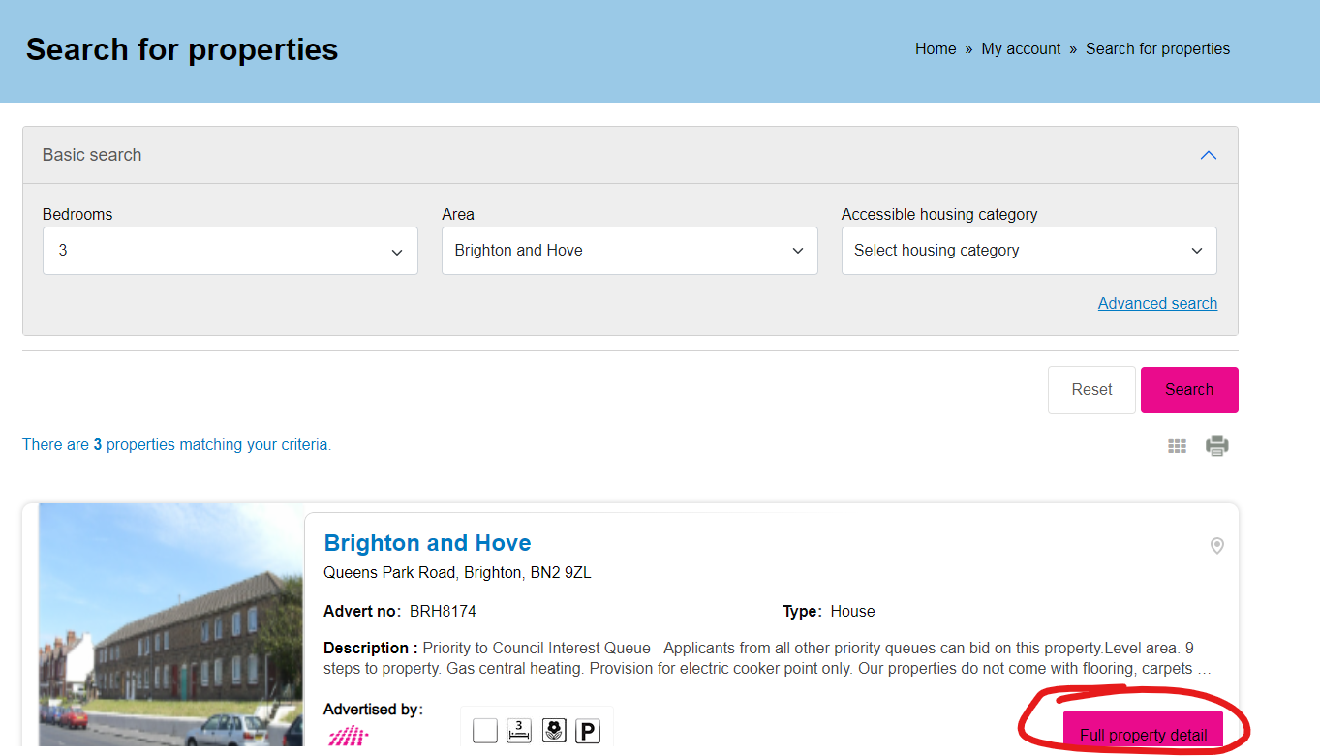
You can read the property overview, see the key facts of the property and see where it is in the map, and of course place a bid
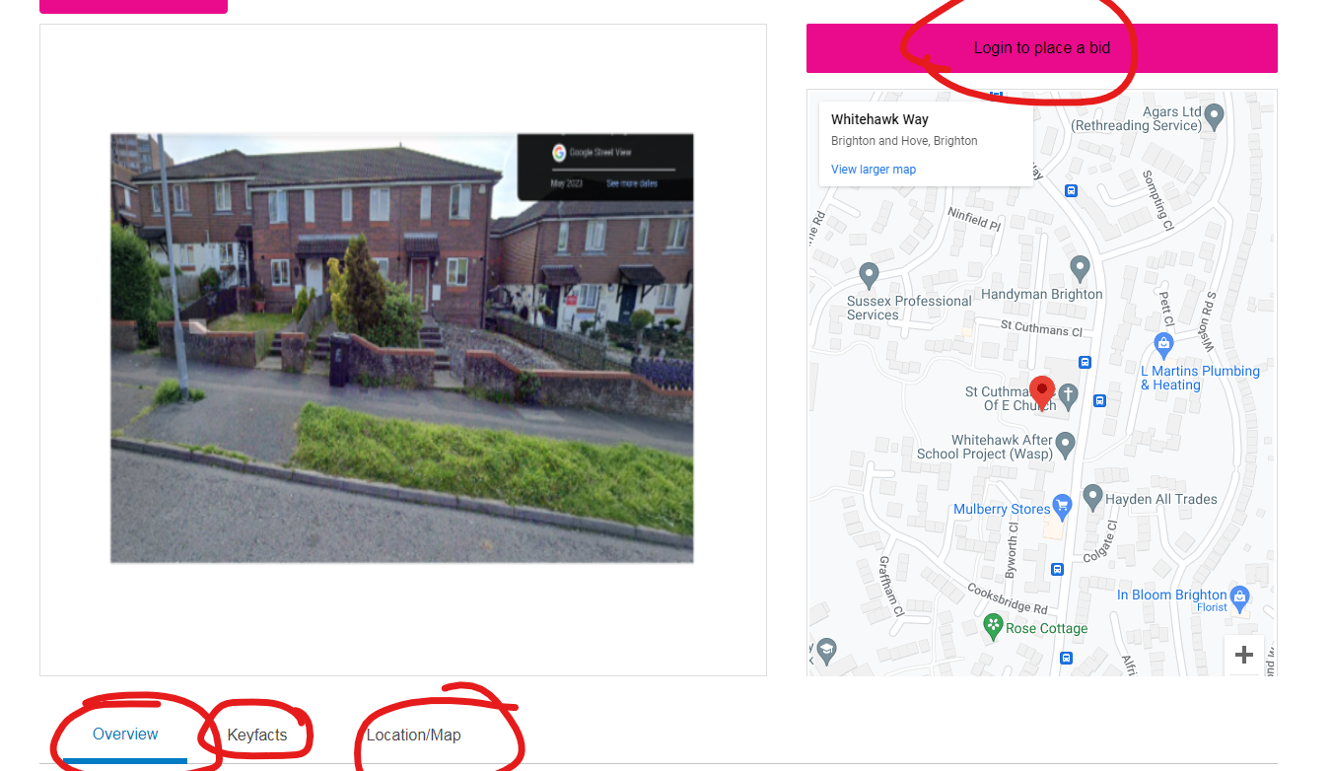
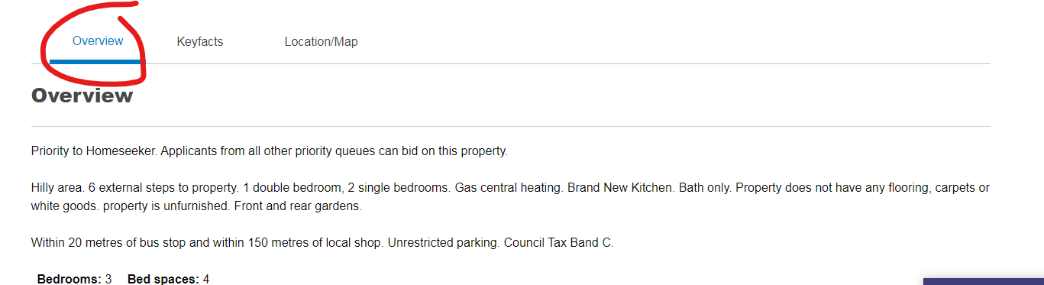

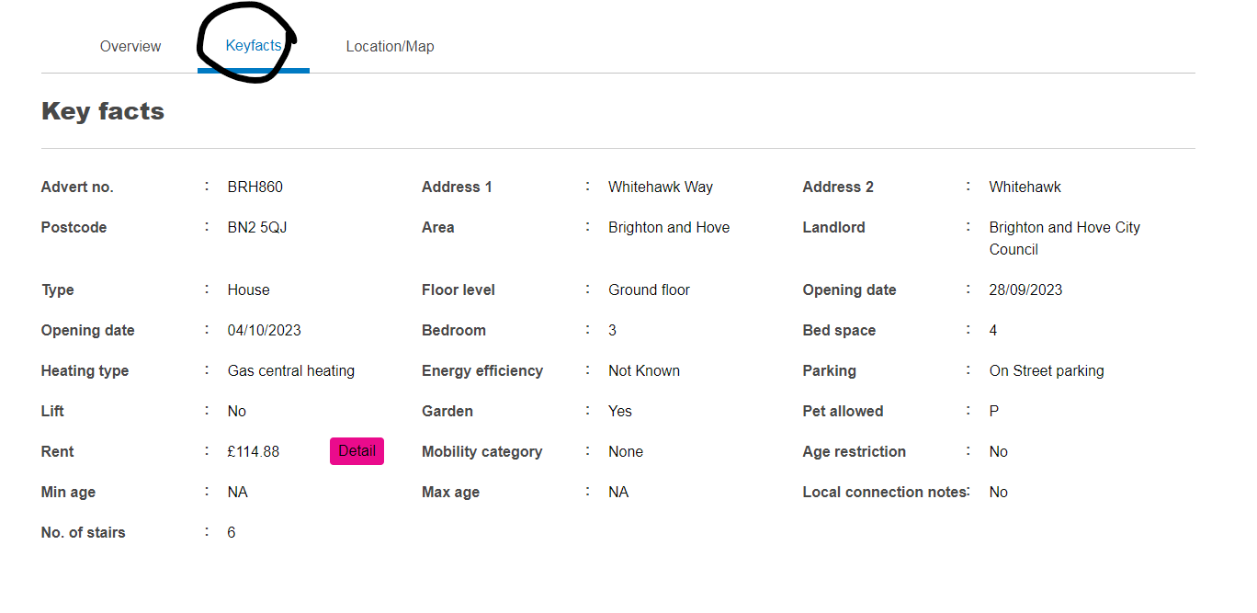
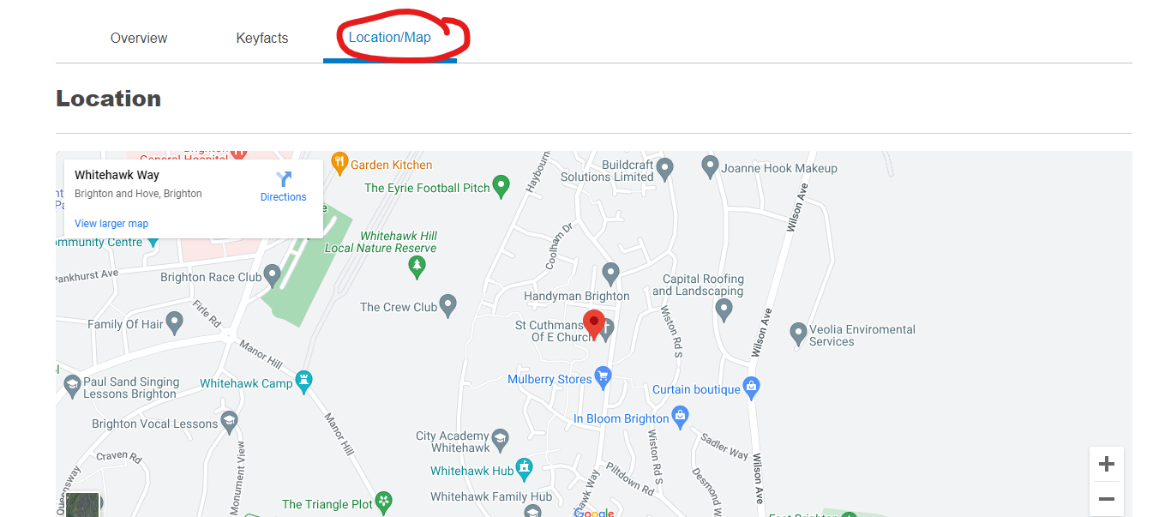

Once you can placed a bid, you can see a confirmation when your bid has been placed
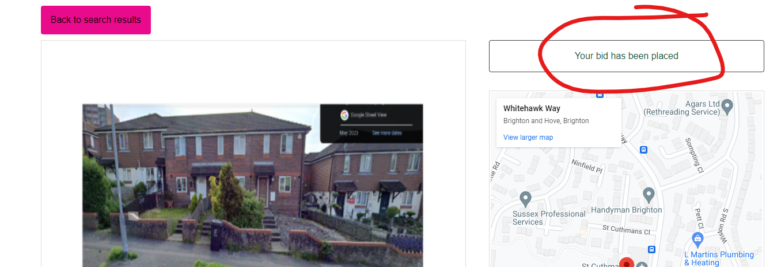

You can also Look at your previous bids
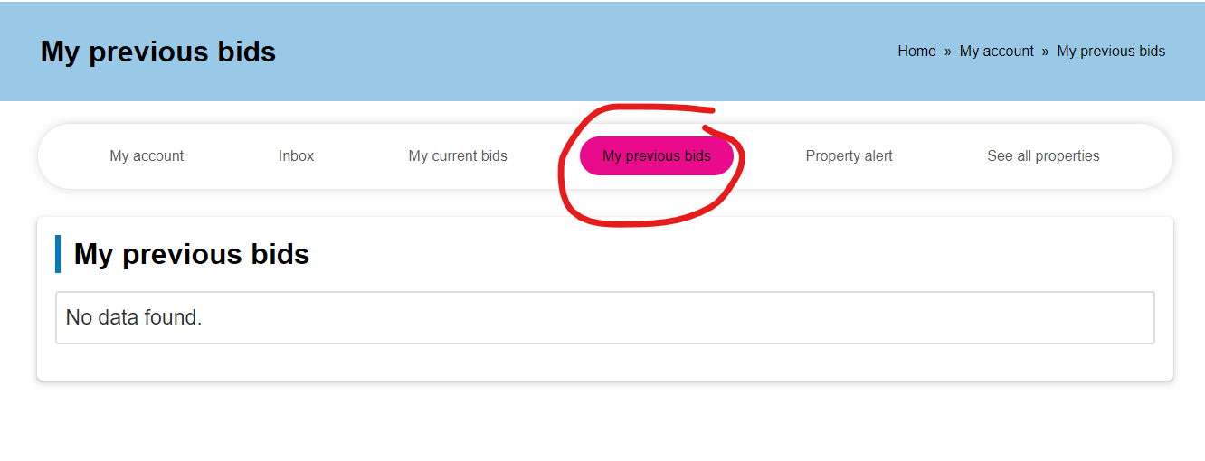
Look at your current bids
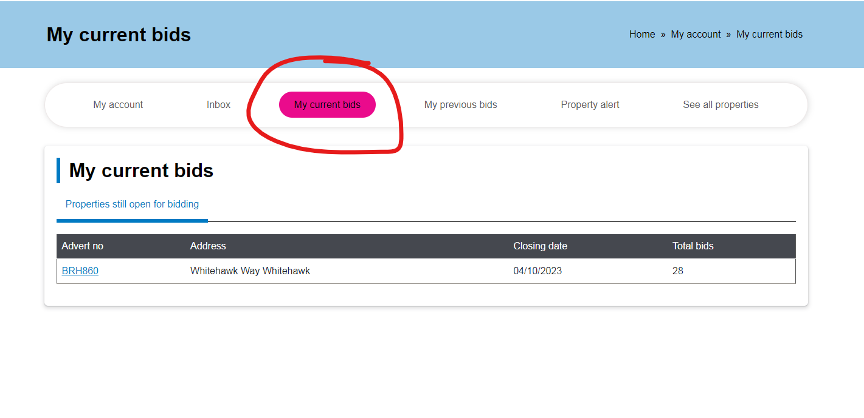

In your current bids – you could withdraw a bid
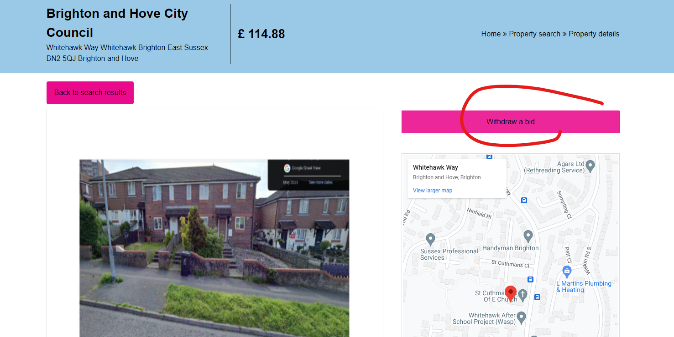

And you will get a confirmation if you withdrawn the property.
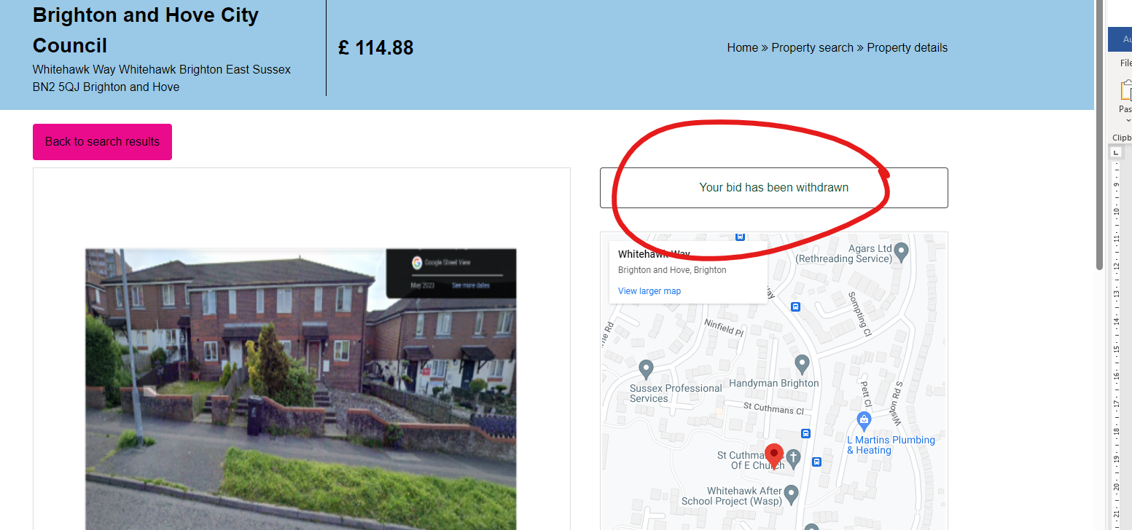
How to create a property alert
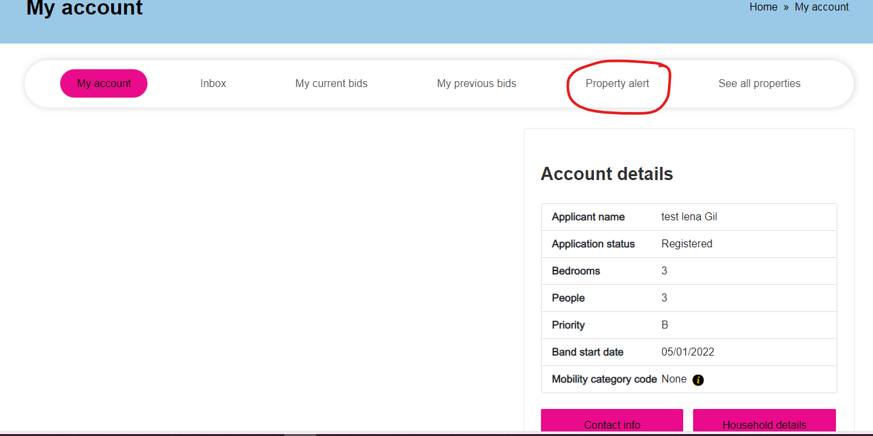

Select your choices and save the search
