Homemove
How to complete a Change of circumstances and update your address

On the Customer portal go to update your application
https://unity.homeconnections.org.uk/SussexHomeMoveOLR/StartPage.aspx?pid=107
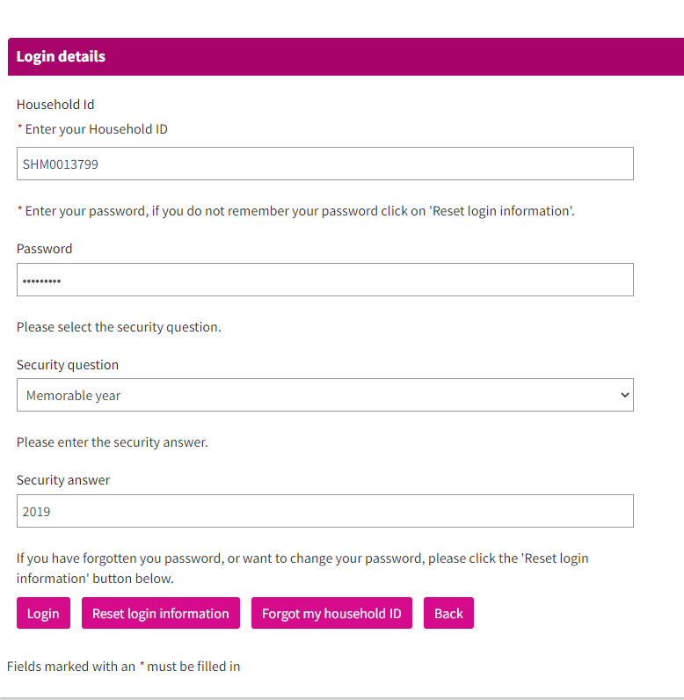
You will be able to see your applications, click - Report a change of circumstances
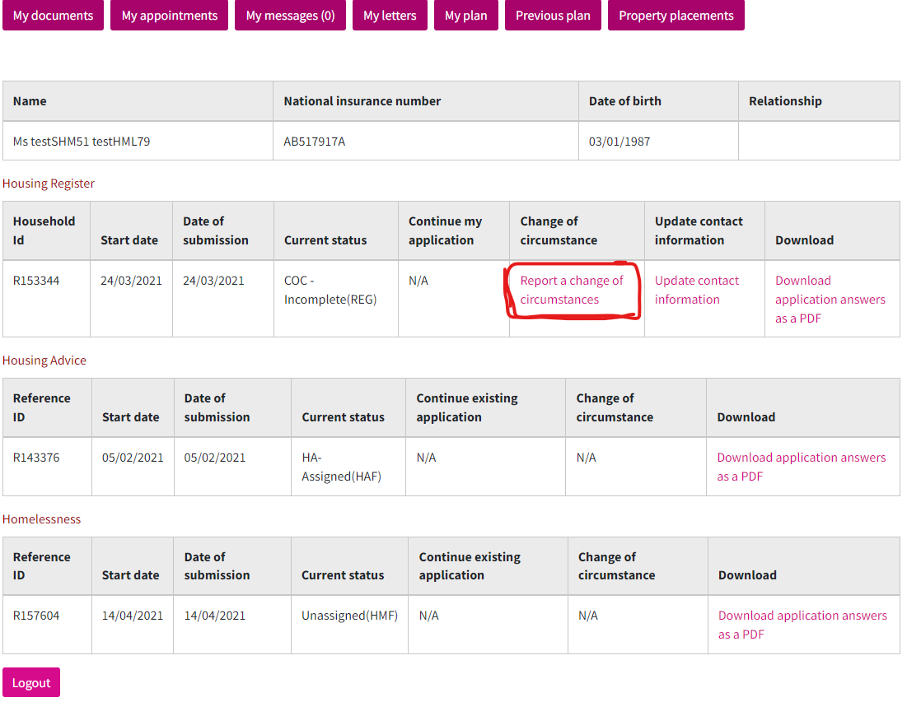
You will see your household, although on the status is completed, please click action view, to update your address

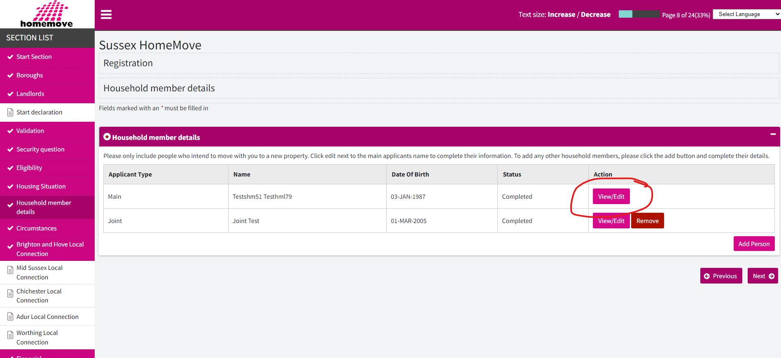

Make sure you edit and close the previous address before enter your new address.
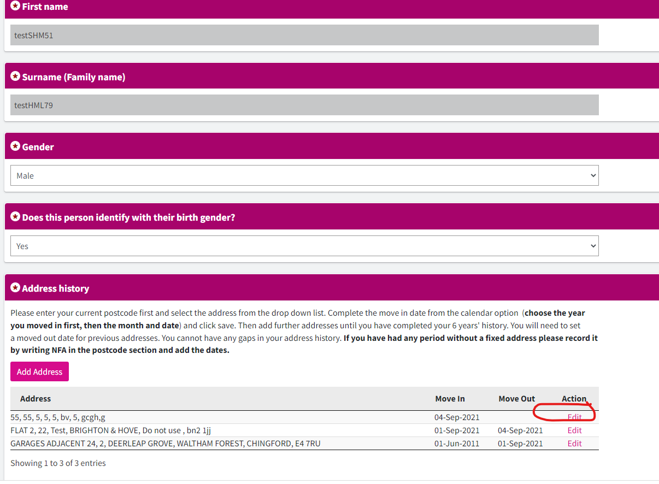

After that ensure you click next to continue updating your application until is showing as completed

