When the applicant has any other status that is not LIVE any case that is waiting information, suspended, removed, change of circumstances waiting, etc will not be able to log in to bid.
For the applicant to be able to add documents, complete a change of circumstances.

Please follow this link
https://unity.homeconnections.org.uk/SussexHomeMoveOLR/StartPage.aspx?pid=107

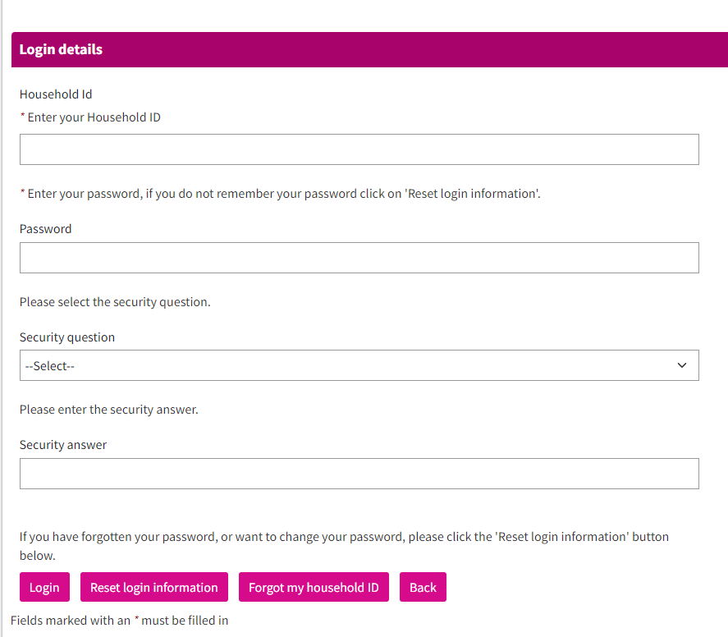

Entering the household identification, password, security question, and answer as you can see the applicant is able to enter the account and you can see there is no a problem accessing the account.
- There the applicant will be able to add documents.
- Complete a change of circumstances.


